LOTRŠČAK TOWER POEM

There's an old, old tower on a hill, 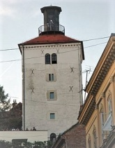
There's a black, black cannon on the windowsill. 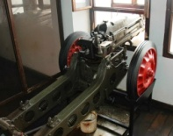
The cannon shoots, shoots each day at noon, 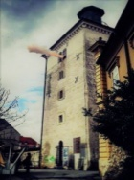
To scare the Ottoman army away, BOOM! 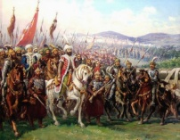
There is a big, big bell at the top. 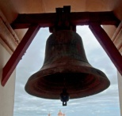
The big bell rings, rings and never stops,
Until the strong, strong gate is shut tight, 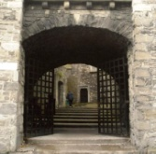
And Gradec is safe, safe for the night. 