ENGLESKI JEZIK - DRUGI RAZRED – 17. SAT (14. 5. 2020.)
- VIDEO: Pogledaj vidio Clothes na link: https://youtu.be/O1TOWlfzbjA

- IGRAJ:
Odjeća https://wordwall.net/resource/2102145
https://wordwall.net/resource/2102253

BILJEŽNICA: Nacrtaj, obojaj i napiši što nosiš danas, ili što voliš nositi. (Koristi udžbenika str. 64 i 65 za pomoć.) Evo 3 primjeraka, vi napraviti samo jednu.

My jacket is red.
My T-shirt is blue. My t-shirt is green. My T-shirt is violet.
My jeans are orange. My jeans are green. My shorts are red.
My trainers are black. My trainers are red and white. My trainers are brown and white.
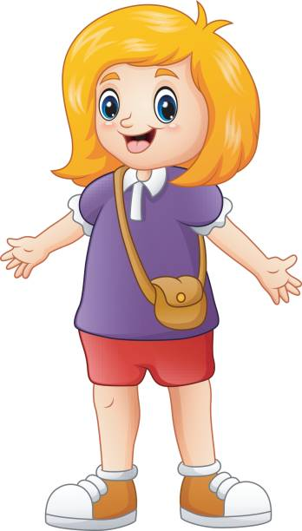

POŠALJITE bilježnicu na email adresu melinda.tupek@skole.hr ili WhatsApp.

- IGRAJ:
https://wordwall.net/resource/2102634

