ENGLESKI JEZIK – ČETVRTI RAZRED - 4. SAT (27. 3. 2020.) 4. ___ Razred
A. Circle the correct words. Zaokruži točan riječ. IME:____________________
1. Our tennis lessons are at / on Sunday. 4. I go to sleep at / on half past nine.
2. Lessons start at / on quarter to nine, 5. The volleyball match is at / on Friday.
3. Janie’s party is at / on Saturday. 6. The football match is at / on two o’clock.
B. Write complete sentences. Use at or on. Poredaj rečenice. Koristi at ili on.
My school / starts / nine o’clock. = My shool starts at nine o'clock.
1. I / play tennis / Sunday. _____________________________________________________
2. We / do our homework / half past five. ________________________________________
3. James / plays football / Wednesdays and Fridays. ______________________________
C. Complete. Dovrši, koristi: listen - go - have – write – take
1. I a lot of emails. 4. Dan the bus school.
2. We to the radio in the morning. 5. Maria skiing in the winter.
3. Sarah a shower at quarter past seven.
D. Complete. Use the present simple negative form of the verb in brackets. Dopuni. Koristi present simple negative formu ovih glagola u zagradima.

- Anna watches TV in the evening. (watch)

- David football on Sundays. (play)

- They computer games. (like)

- Joe and Ned swimming in the evening. (go)

- Richard badges. (collect)

6. Sarah coffee for breakfast. (drink)
E. What are they doing? Što rade? Napiši ispod slike.
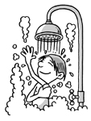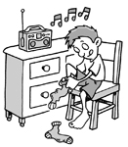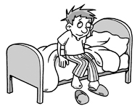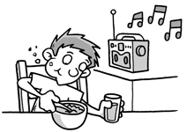
1. 2. 3. 4. 5. 6.

F. Complete the questions. Use do or does. Dopuni pitanje. Koristi do ili does.
  - ____________ you drink coffee? 3. ____________ Maria like horses?
  - _________ they play the piano? 4. ___________ Jane go to dance class?
3. ________ your dad play basetball? 5. ____________ your parents drive a car?

G. Choose the correct word. Izaberi točan rijeć. Koristi: do, does, doesn't, don't
1.Does James watch TV? No, he __________. 3. Do you play an instrument? No, I _________.
2. Does your brother like snakes? Yes, he ______. 4. Does your cat like dogs? No, it ______.
H. Write the time on the clocks. Napiši vrijeme na satu riječima. Npr. It’s ten past eight.
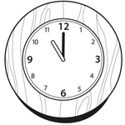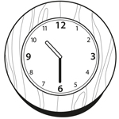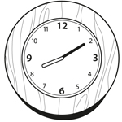
1._________________________2.________________________3._______________________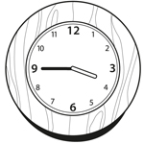 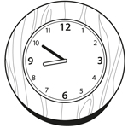 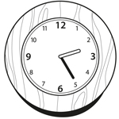
4._________________________5.__________________________6.________________________
I. Complete. Dopuni.
1.I ____________ lunch at school. 4. I __________ to sleep after I read my book.
2. I ________ to school with my friends. 5.I _______ the bus to school in the morning.
3. I ___________ TV with my parents. 6. I ____________ to music on my MP3 player.
J. Translate. Prevodi. golf _____________ football _________________
volleyball _____________ tennis ________________ ice hockey ______________
piano ________________ guitar _________________ baseball ________________
K. Complete. Poredaj. basketball _______________
1. get up / time / do / what / you?_________________________________________
2. quarter / at / past / get up / I / six _______________________________________
3. bus / school / to / the / take / you / do?_____________________________________
4. don't / I / no ______________________________________________________________

Poštovani roditelji,
Ako nemožete printati listiće, neka vaše dijete samo napiše odgovore u bilježnicu na ovaj način. To poslikajte i pošaljite meni na moj email adresu: melinda.tupek@skole.hr do petka. Hvala na suradnju, Teacher Melinda

Ime: ________________________________________ Razred: 3._____

- (Napiši ON ili AT.) G.(Napiši odgovore.) 1. 1.
2. 2.
3. 3.
4. 4.
5.
6.

- (Napiši rećenice.) H. (Napiši vrijeme na satu.)
1. 1.
2. 2.
3. 3.
4.
- 1. 5.
2. 6.
3.
4.
5.

- 1. I. (Napiši rećenice.)
2. 1.
3. 2.
4. 3.
5. 4.
6. 5.
6.
- 1.
2. J. (Prevodi.)
3.
4.
5.
6. K. (Napiši rećenice.)
1.
- 1. 2.
2. 3.
3. 4.
4.
5.

